**[10 Windows Tweaking Myths Debunked](http://www.howtogeek.com/173648/10-windows-tweaking-myths-debunked/" \o "10 Windows Tweaking Myths Debunked)**

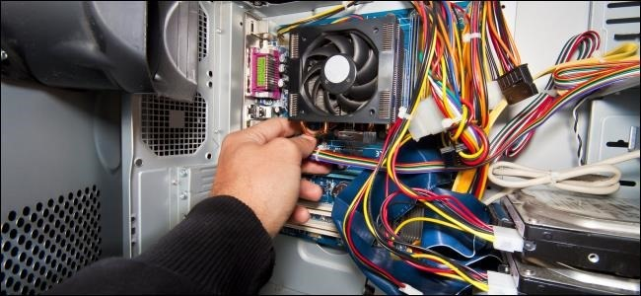

Windows is big, complicated, and misunderstood. You’ll still stumble across bad advice from time to time when browsing the web. These Windows tweaking, performance, and system maintenance tips are mostly just useless, but some are actively harmful.

Luckily, most of these myths have been stomped out on mainstream sites and forums. However, if you start searching the web, you’ll still find websites that recommend you do these things.

Erase Cache Files Regularly to Speed Things Up

You can free up disk space by running an application like [CCleaner](http://www.howtogeek.com/172820/beginner-geek-what-does-ccleaner-do-and-should-you-use-it/), another temporary-file-cleaning utility, or even the Windows Disk Cleanup tool. In some cases, you may even see an old computer speed up when you erase a large amount of useless files.

However, running CCleaner or similar utilities every day to erase your browser’s cache won’t actually speed things up. It will slow down your web browsing as your web browser is forced to redownload the files all over again, and reconstruct the cache you regularly delete. If you’ve installed CCleaner or a similar program and run it every day with the default settings, you’re actually slowing down your web browsing. Consider at least preventing the program from wiping out your web browser cache.

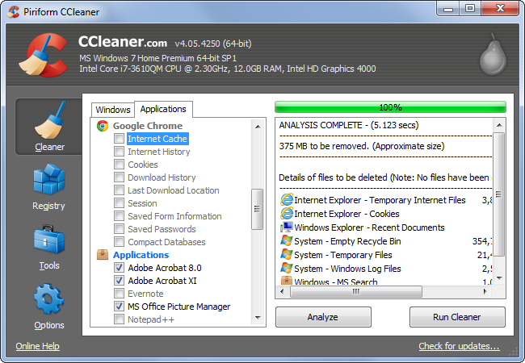

Enable ReadyBoost to Speed Up Modern PCs

Windows still prompts you to [enable ReadyBoost](http://www.howtogeek.com/123780/htg-explains-is-readyboost-worth-using/) when you insert a USB stick or memory card. On modern computers, this is completely pointless — ReadyBoost won’t actually speed up your computer if you have at least 1 GB of RAM. If you have a very old computer with a tiny amount of RAM — think 512 MB — ReadyBoost may help a bit. Otherwise, don’t bother.

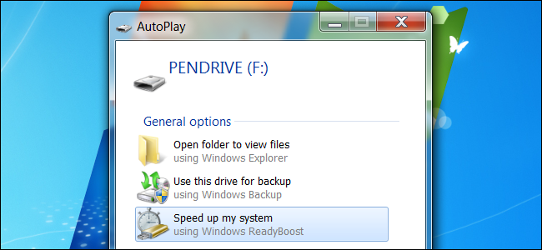

Open the Disk Defragmenter and Manually Defragment

On Windows 98, users had to manually open the defragmentation tool and run it, ensuring no other applications were using the hard drive while it did its work. Modern versions of Windows are capable of defragmenting your file system while other programs are using it, and [they automatically defragment your disks for you](http://www.howtogeek.com/97723/htg-explains-do-you-really-need-to-defrag-your-pc/).

If you’re still opening the Disk Defragmenter every week and clicking the Defragment button, you don’t need to do this — Windows is doing it for you unless you’ve told it not to run on a schedule. Modern computers with solid-state drives don’t have to be defragmented at all.

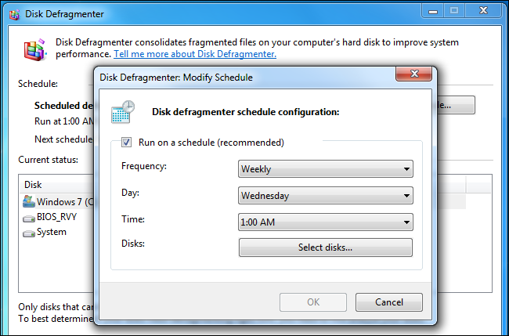

Disable Your Pagefile to Increase Performance

When Windows runs out of empty space in RAM, it swaps out data from memory to a [pagefile](http://www.howtogeek.com/126430/htg-explains-what-is-the-windows-page-file-and-should-you-disable-it/) on your hard disk. If a computer doesn’t have much memory and it’s running slow, it’s probably moving data to the pagefile or reading data from it.

Some Windows geeks seem to think that the pagefile is bad for system performance and disable it completely. The argument seems to be that Windows can’t be trusted to manage a pagefile and won’t use it intelligently, so the pagefile needs to be removed.

As long as you have enough RAM, it’s true that you can get by without a pagefile. However, if you do have enough RAM, Windows will only use the pagefile rarely anyway. [Tests have found](http://www.howtogeek.com/95915/heres-why-disabling-the-windows-pagefile-is-pointless/) that disabling the pagefile offers no performance benefit.

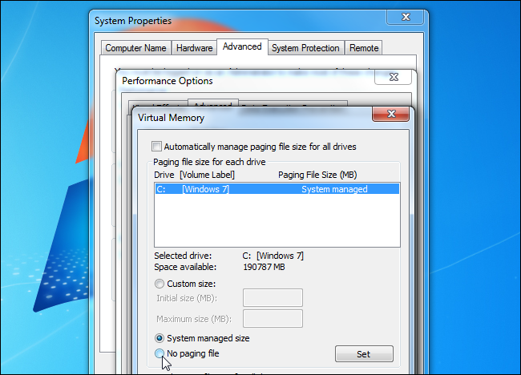

Enable CPU Cores in MSConfig

Some websites claim that Windows may not be using all of your CPU cores or that you can speed up your boot time by increasing the amount of cores used during boot. They direct you to the MSConfig application, where you can indeed select an option that appears to increase the amount of cores used.

In reality, Windows always uses the maximum amount of processor cores your CPU has. (Technically, only one core is used at the beginning of the boot process, but the additional cores are quickly activated.) Leave this option unchecked. It’s just a debugging option that allows you to set a maximum number of cores, so it would be useful if you wanted to force Windows to only use a single core on a multi-core system — but all it can do is restrict the amount of cores used.

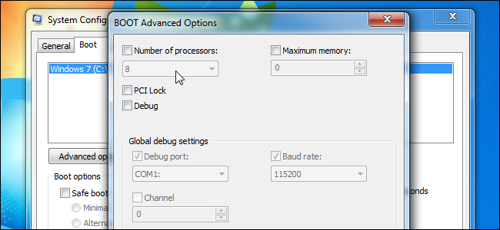

Clean Your Prefetch To Increase Startup Speed

Windows watches the programs you run and creates .pf files in its Prefetch folder for them. The Prefetch feature works as a sort of cache — when you open an application, Windows checks the Prefetch folder, looks at the application’s .pf file (if it exists), and uses that as a guide to start preloading data that the application will use. This helps your applications start faster.

Some Windows geeks have misunderstood this feature. They believe that Windows loads these files at boot, so your boot time will slow down due to Windows preloading the data specified in the .pf files. They also argue you’ll build up useless files as you uninstall programs and .pf files will be left over. In reality, Windows only loads the data in these .pf files when you launch the associated application and only stores .pf files for the 128 most recently launched programs.

If you were to regularly clean out the Prefetch folder, not only would programs take longer to open because they won’t be preloaded, Windows will have to waste time recreating all the .pf files.

You could also modify the PrefetchParameters setting to disable Prefetch, but there’s no reason to do that. Let Windows manage Prefetch on its own.

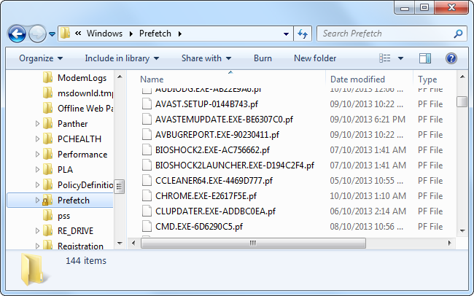

Disable QoS To Increase Network Bandwidth

[Quality of Service (QoS)](http://www.howtogeek.com/75660/the-beginners-guide-to-qos-on-your-router/) is a feature that allows your computer to prioritize its traffic. For example, a time-critical application like Skype could choose to use QoS and prioritize its traffic over a file-downloading program so your voice conversation would work smoothly, even while you were downloading files.

Some people incorrectly believe that QoS always reserves a certain amount of bandwidth and this bandwidth is unused until you disable it. This is untrue. In reality, 100% of bandwidth is normally available to all applications unless a program chooses to use QoS. Even if a program does choose to use QoS, the reserved space will be available to other programs unless the program is actively using it. No bandwidth is ever set aside and left empty.

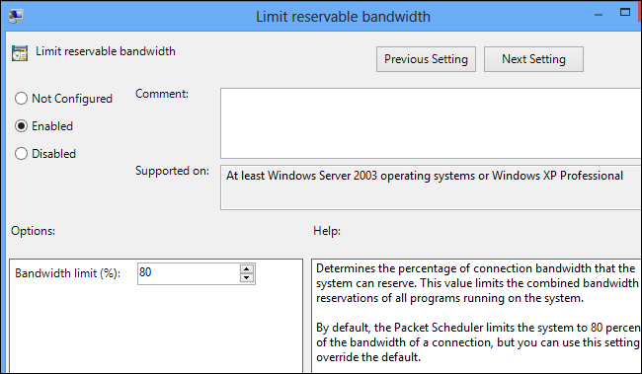

Set DisablePagingExecutive to Make Windows Faster

The DisablePagingExecutive registry setting is set to 0 by default, which allows drivers and system code to be paged to the disk. When set to 1, drivers and system code will be forced to stay resident in memory. Once again, some people believe that Windows isn’t smart enough to manage the pagefile on its own and believe that changing this option will force Windows to keep important files in memory rather than stupidly paging them out.

If you have more than enough memory, changing this won’t really do anything. If you have little memory, changing this setting may force Windows to push programs you’re using to the page file rather than push unused system files there — this would slow things down. This is an option that may be helpful for debugging in some situations, not a setting to change for more performance.

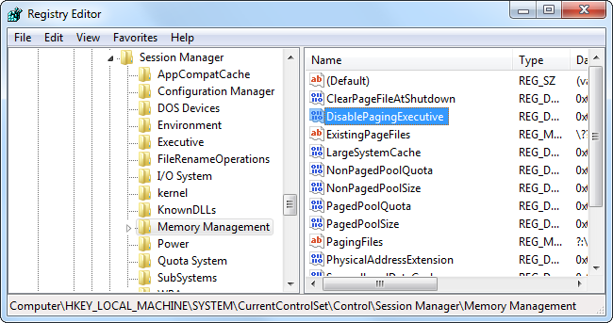

Process Idle Tasks to Free Memory

Windows does things, such as creating scheduled system restore points, when you step away from your computer. It waits until your computer is “idle” so it won’t slow your computer and waste your time while you’re using it.

Running the “Rundll32.exe advapi32.dll,ProcessIdleTasks” command forces Windows to perform all of these tasks while you’re using the computer. This is completely pointless and won’t help free memory or anything like that — all you’re doing is forcing Windows to slow your computer down while you’re using it. This command only exists so benchmarking programs can force idle tasks to run before performing benchmarks, ensuring idle tasks don’t start running and interfere with the benchmark.

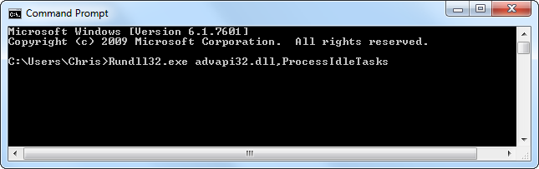

Delay or Disable Windows Services

There’s no real reason to disable Windows services anymore. There was a time when Windows was particularly heavy and computers had little memory — think Windows Vista and those “Vista Capable” PCs Microsoft was sued over. Modern versions of Windows like Windows 7 and 8 are lighter than Windows Vista and computers have more than enough memory, so you won’t see any improvements from disabling system services included with Windows.

Some people argue for not disabling services, however — they recommend setting services from “Automatic” to “Automatic (Delayed Start)”. By default, the Delayed Start option just starts services two minutes after the last “Automatic” service starts.

Setting services to Delayed Start won’t really speed up your boot time, as the services will still need to start — in fact, it may lengthen the time it takes to get a usable desktop as services will still be loading two minutes after booting. Most services can load in parallel, and loading the services as early as possible will result in a better experience. The “Delayed Start” feature is primarily useful for system administrators who need to ensure a specific service starts later than another service.

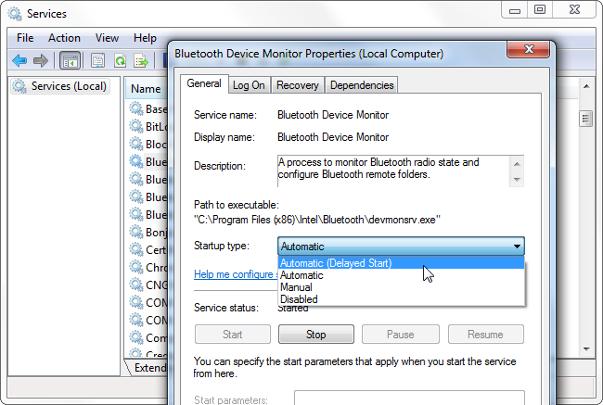

If you ever find a guide that recommends you set a little-known registry setting to improve performance, take a closer look — the change is probably useless.

Want to actually speed up your PC? Try [disabling useless startup programs that run on boot](http://www.howtogeek.com/173347/beginner-geek-everything-you-need-to-know-about-disabling-startup-programs-on-windows/), increasing your boot time and consuming memory in the background. This is a much better tip than doing any of the above, especially considering most Windows PCs come [packed to the brim with bloatware](http://www.howtogeek.com/163303/how-computer-manufacturers-are-paid-to-make-your-laptop-worse/).